AI ASSISSTED CODING LAB-6.2
NAME : J.SANJANA
ROLNO : 2503A52379
BATCH : 13
TASK-1:
Prompt:
Generate a clean and beginner-friendly Python program using object-oriented programming. Create a class named Student with attributes name, roll_no, and marks. Include an __init__() constructor to initialize these attributes. Add a method named is_pass() that returns True if the student's marks are greater than or equal to 40; otherwise, return False. Create a sample Student object and print the student's details along with whether the student has passed or failed. Include comments to explain the code.
INPUT:
class Student:
def __init__(self, name, roll_no, marks):
self.name = name
self.roll_no = roll_no
self.marks = marks

def is_pass(self):
return self.marks >= 40

student = Student("John", 101, 75)
print("Name:", student.name)
print("Roll No:", student.roll_no)
print("Marks:", student.marks)

if student.is_pass():
print("Result: Pass")
else:
print("Result: Fail")
OUTPUT:
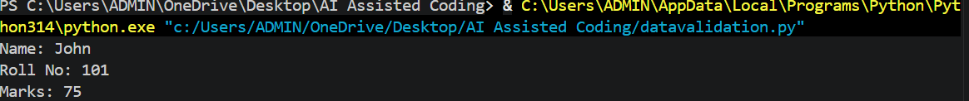
TASK-2:
PROMPT:
Generate a clean and beginner-friendly Python program to print a right-angled triangle star pattern. First, create a function using a for loop to print the pattern for a given number of rows. Then, create another function that generates the exact same pattern using a while loop. Use * as the pattern character, include an example with 5 rows, and display the output. Add clear comments to explain each part of the code.
INPUT:
def triangle_for(rows):
for i in range(1, rows + 1):
print("*" * i)
triangle_for(5)
def triangle_while(rows):
i = 1
while i <= rows:
print("*" * i)
i += 1
triangle_while(5)
OUTPUT:
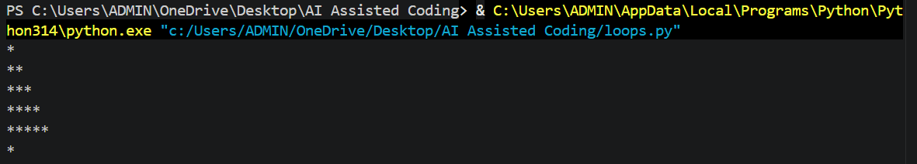
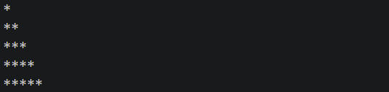
TASK-3:
PROMPT:
Generate a clean and beginner-friendly Python program that defines a function named check_number(number) to determine whether a given number is positive, negative, or zero using if-elif-else statements. The function should return an appropriate message such as "Positive", "Negative", or "Zero". Test the function with multiple inputs, including positive numbers, negative numbers, and zero. Display the results clearly and add comments to explain the code.
INPUT:
def check_number(number):
if number > 0:
return "Positive"
elif number < 0:
return "Negative"
else:
return "Zero"
numbers = [10, -5, 0, 25, -12]
for num in numbers:
print(num, "is", check_number(num))
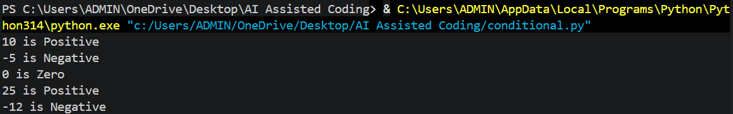
TASK-4:
PROMPT:
Generate a clean and beginner-friendly Python program that defines a function named check_discount(age, is_member) to determine a person's discount eligibility using nested if statements. If the age is 60 or above, display "Eligible for Senior Discount". Inside the appropriate conditions, check whether the person is a member and, if so, display "Eligible for Additional Member Discount". If the person is not eligible for a senior discount or is not a member, display suitable messages. Include multiple test cases with different ages and membership statuses, and add clear comments to explain the nested if logic.
INPUT:
def check_discount(age, is_member):
if age >= 60:
print("Eligible for Senior discount")

if is_member:
print("Eligible for Additional member discount")
else:
print("Not eligible for Additional member discount")

else:
print("Not eligible for Senior discount")

if is_member:
print("Eligible for Additional member discount")
else:
print("Not eligible for any discount")
check_discount(65, True)
print()
check_discount(65, False)
print()
check_discount(30, True)
print()
check_discount(25, False)
OUTPUT:
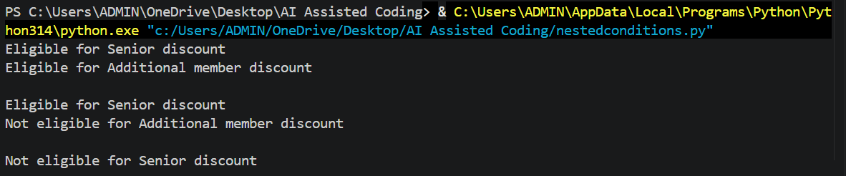
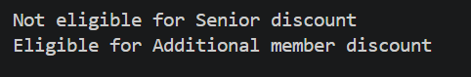
TASK-5:
PROMPT:
Generate a clean and beginner-friendly Python program using object-oriented programming. Create a class named Circle with a radius attribute initialized through the __init__() constructor. Add an area() method to calculate and return the area of the circle and a circumference() method to calculate and return its circumference. Use Python's math.pi for accurate calculations. Create a sample Circle object with a radius of 5, call both methods, and display the radius, area, and circumference clearly. Add simple comments to explain the code.
INPUT:
import math
class Circle:
def __init__(self, radius):
self.radius = radius

def area(self):
return math.pi * self.radius ** 2

def circumference(self):
return 2 * math.pi * self.radius
circle = Circle(5)
print("Radius:", circle.radius)
print("Area:", circle.area())
print("Circumference:", circle.circumference())
OUTPUT:
